**Assignment – Bank Details**

Shaun Pritchard

Rasmussen College

QMB3200

Kimberly Powell

August 08, 2020

**Assignment – Bank Details**

In this assignment I developed SAS script to meet the standards guidelines and print a report with PROC REPORT outputting the bank name, state and closing data of the bank. I adjusted the headers in the columns with DEFINE function and ordered all data in descending order by data of closing. See the code below.

**Note:** I did have to pull in the datafile into a dataset first. When using PROC REPORT DATA=’/some_folder/filepath.sas’ the program would through errors, so I pulled in the data into a dataset first then ran the functions of the script for the assignment.

**Code:**

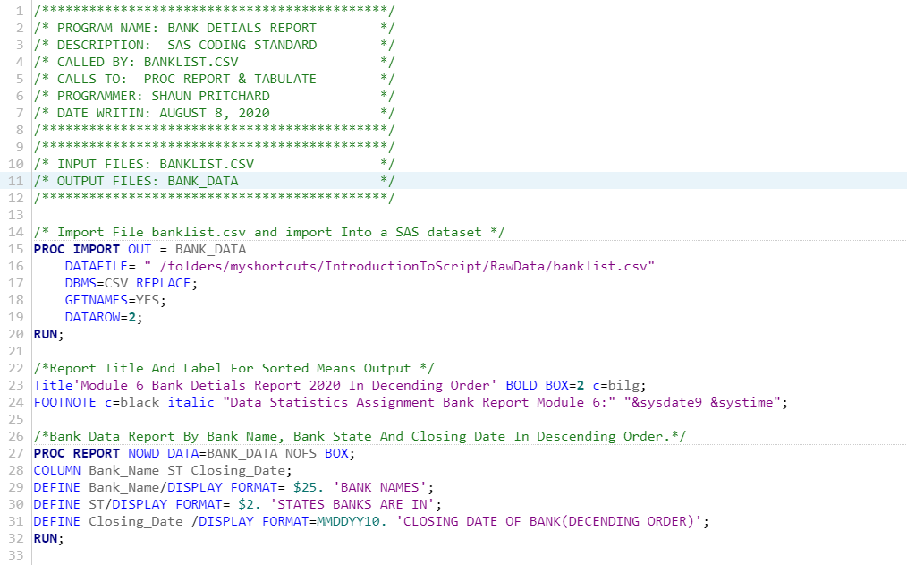

**Code Output (Using PROC REPORT):**

